**Flaw Detection System - Reactor Engineering Division**

**Overview**

This Flaw Detection System is designed to analyze images for flaws within reactor engineering components. It processes selected images, identifies flaws, and calculates their depths. The system also generates a 3D surface plot of the detected flaws and provides a detailed report in PDF format.

**Features**

1. **Image Loading and Saving**: Allows users to select multiple images, save them, and display the resized version.

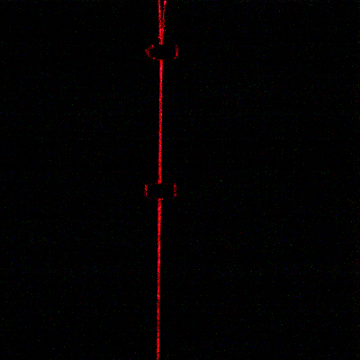

1. **Image Processing**: Converts images to grayscale, applies Gaussian blur, and performs thresholding to highlight flaws.

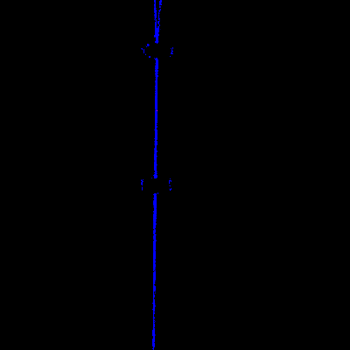

1. **3D Surface Plot**: Generates a 3D plot showing the depth of the flaws.

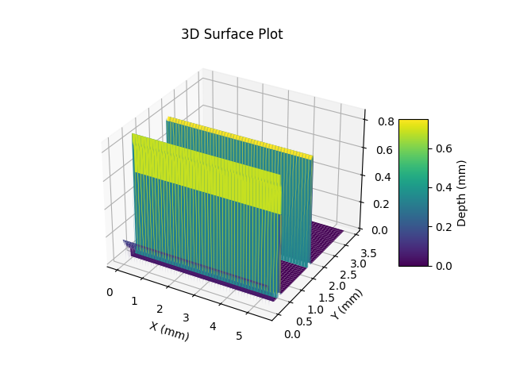

1. **Flaw Depth Calculation**: Calculates the depth of each detected flaw and displays it in a table.

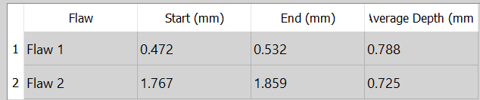

1. **Report Generation**: Saves the flaw data and plots into a PDF report.